**Homework-1 (*Chapter 2)***

1. Draw a recording of a typical action potential. Label the axes and the key features of the action potential. Identify the underlying events for each of the following:

Rising phase

Overshoot

Peak

Falling phase

Undershoot

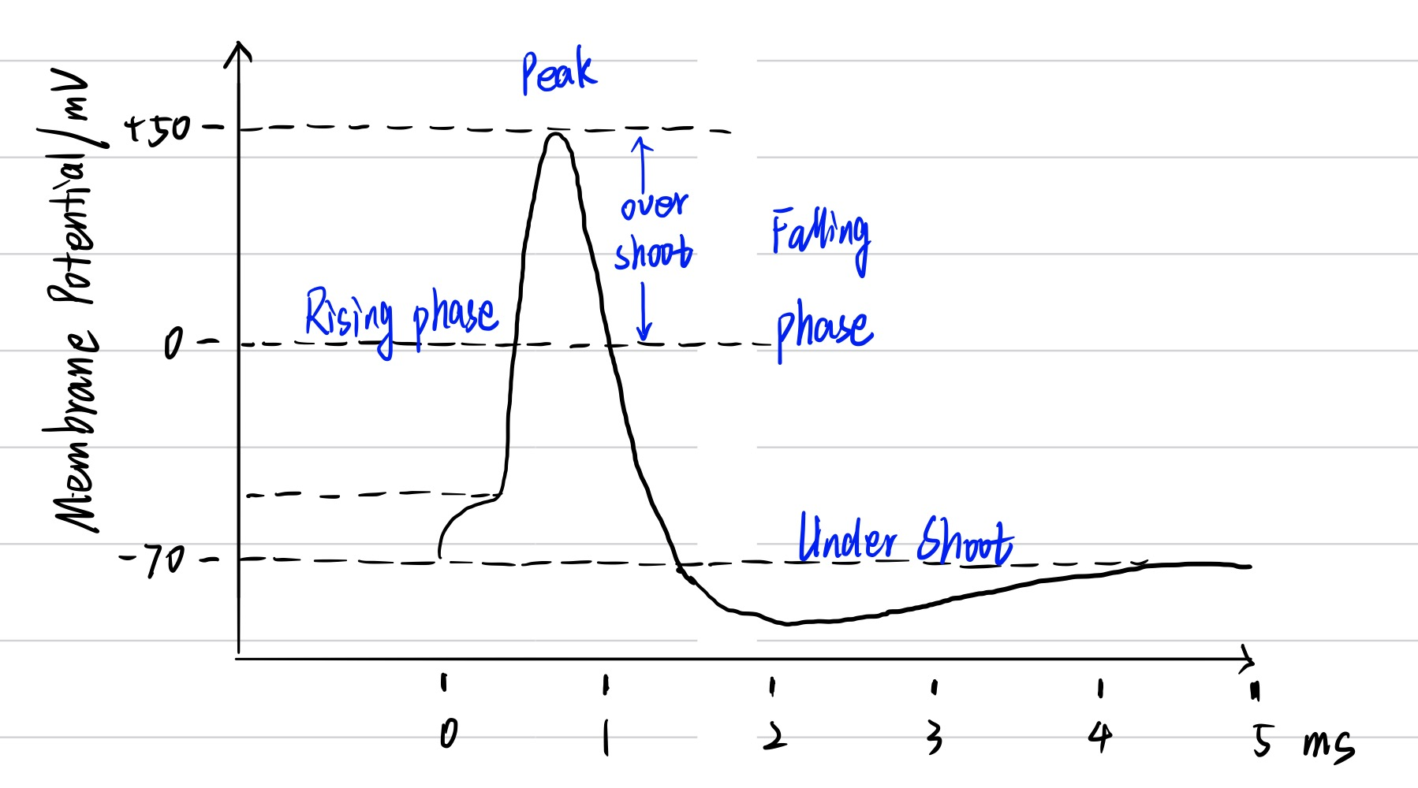

2. Suppose a water-filled aquarium is divided into two compartments by a membrane that is impermeable to all ions. If KCl is added to one compartment, what will happen to the distribution of ions? Is there a potential difference between the two compartments? What will happen to the membrane potential if the membrane suddenly becomes selectively permeable to K+ (but not to Cl–)? What would happen if you then added NaCl to one compartment only?

（1）Nothing will happen.

（2）No

（3）Membrane potential will approximate to K+ equilibrium potential.

（4）Nothing will change because the membrane isn’t permeable to Na+.

3. What is the magnitude of a typical neuron’s resting membrane potential? Why do neurons and other cells have a negative resting membrane potential?

（1）It is equal to K+ equilibrium potential and the magnitude of it is usually about -70mV.

（2） Most of animal cells’ plasma membranes’ conduction of K+ is much higher than that of other ions while resting. Hence, the resting potential of cells is determined by intracellular and extracellular K+ concentration for K+ tend to achieve its electrochemical equilibrium. When K+ reached its electrochemical equilibrium, there will be a potential, which is across the membrane, equal to K+ equilibrium potential and this potential is resting potential of cell. For intracellular concentration of K+ is usually higher than extracellular, we can calculate that resting potential is more negative than 0mV according to Goldman Equation.

4. Distinguish between hyperpolarization and depolarization.

Hyperpolarization is a change of cell potential with makes the potential more negative while depolarization makes it more positive.

5. What is meant by electrochemical equilibrium?

There are two factors which influence concentration of ions between membrane which is permeable to ions. They are electrical and chemical gradients. When the electrical and chemical gradients are equal, the ions concentration across membrane will be stable and we consider ions reached electrochemical equilibrium.

6. Write out the Nernst equation. Explain how it could be used to determine the equilibrium potential for K+.

When we determine the equilibrium potential for K+:

Z=1

[X+]o=extracellular concentration of K+

[X-]i=intracellular concentration of K+

7. Suppose you are recording a neuron’s resting membrane potential. If you added KCl to the external medium, what would happen to the resting potential? Compare this to what would happen if you had added the same amount of NaCl. What can you conclude from this comparison?

（1）The resting potential will be more positive.

（2）There won’ t be significant change

（3）Resting potential of the cell is determined by intra- and extracellular concentration of K+ but not Na+

**Key Terms**

active transporter: The process of enzyme transport ions or molecular from low concentration to high concentration and consume energy.

Goldman equation: It is an equation to determine cross-membrane potential by concentration of ions which are permeable through membrane.

receptor potential: Receptor potential is the electrical signal which is converted from stimuli sensors received

threshold potential: The lowest potential which can induce an active potential.